Exp no:10 Implement Boundary condition between two different dielectric medium in Magnetic Field
and find the relative permeability of the different medium.

Aim:
To write program for Boundary condition between two different dielectric media in magnetic field using
SCILAB.
Software required:
•SCILAB version 6.0.1
PROGRAM :
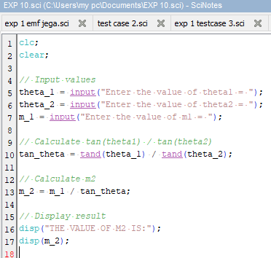
OUTPUT :
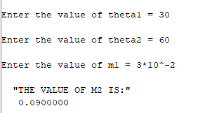

CALCULATIONS :
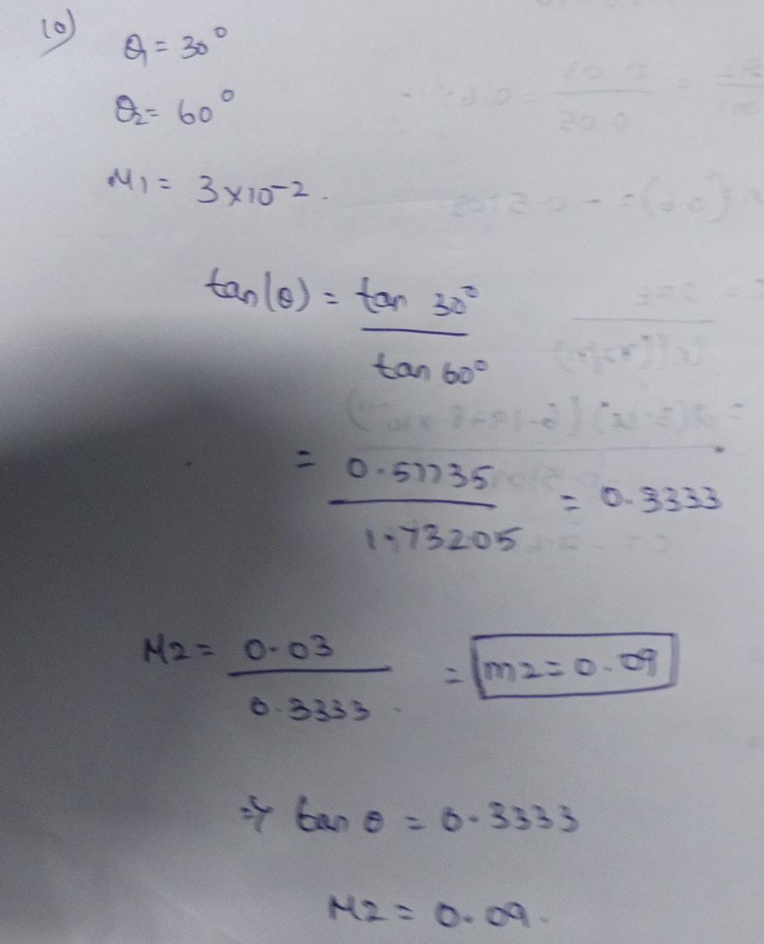
CASE 1 :
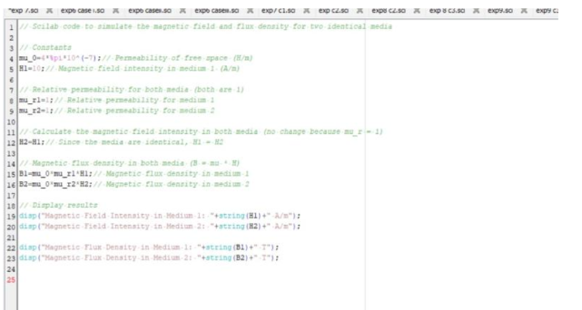
OUTPUT :
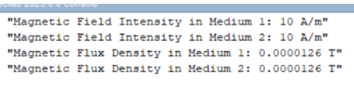
CASE 2 :
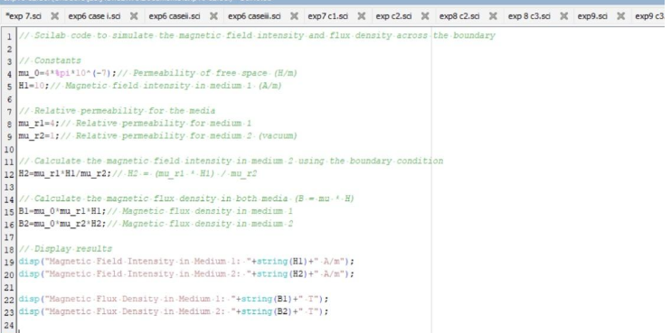
OUTPUT :
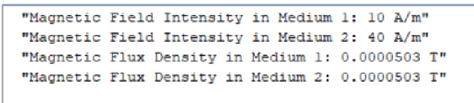
CASE 3 :
